Present by Nazia Siraj

GICIC 00443199

Friday 9am-12pm

Mentor Sir Humza Syed

Day-5: Testing, Error handling and Backend IntegrationRefinement

MarketPlace-Builder-

Hackathon

Day-5: Testing, Error handling and Backend Integration

Refinement

Overview

The main goal of DAY-5 was to prepare the marketplace for real-world deployment by thoroughly testing all components, identifying and resolving errors, optimizing performance, and refining backend integrations. This involved performing functional testing to ensure core features like product listings, search, and cart operations worked as expected, implementing error handling to display user-friendly messages and fallback UI for API failures, optimizing performance by reducing load times and compressing images, and conducting cross-browser and device testing to ensure consistent user experience. Additionally, security testing was conducted to validate inputs and secure API communication.

Product Listing Page

**Problem Faced**

During testing, while navigating to the product listing page, I observed that the images were not loading, and instead, an error message stating "Image fetch failed" was displayed. The issue was traced back to a network problem that caused the failure in fetching images from the sanity. This disruption was preventing the page from displaying the correct product images, which is a critical part of the marketplace's user experience.

**Resolution**

The issue was resolved by addressing the network connectivity problem. Once the network was restored, the image fetching functionality resumed as expected, and the product images were displayed correctly on the page. After the fix, the test was repeated, and the images loaded successfully without errors.

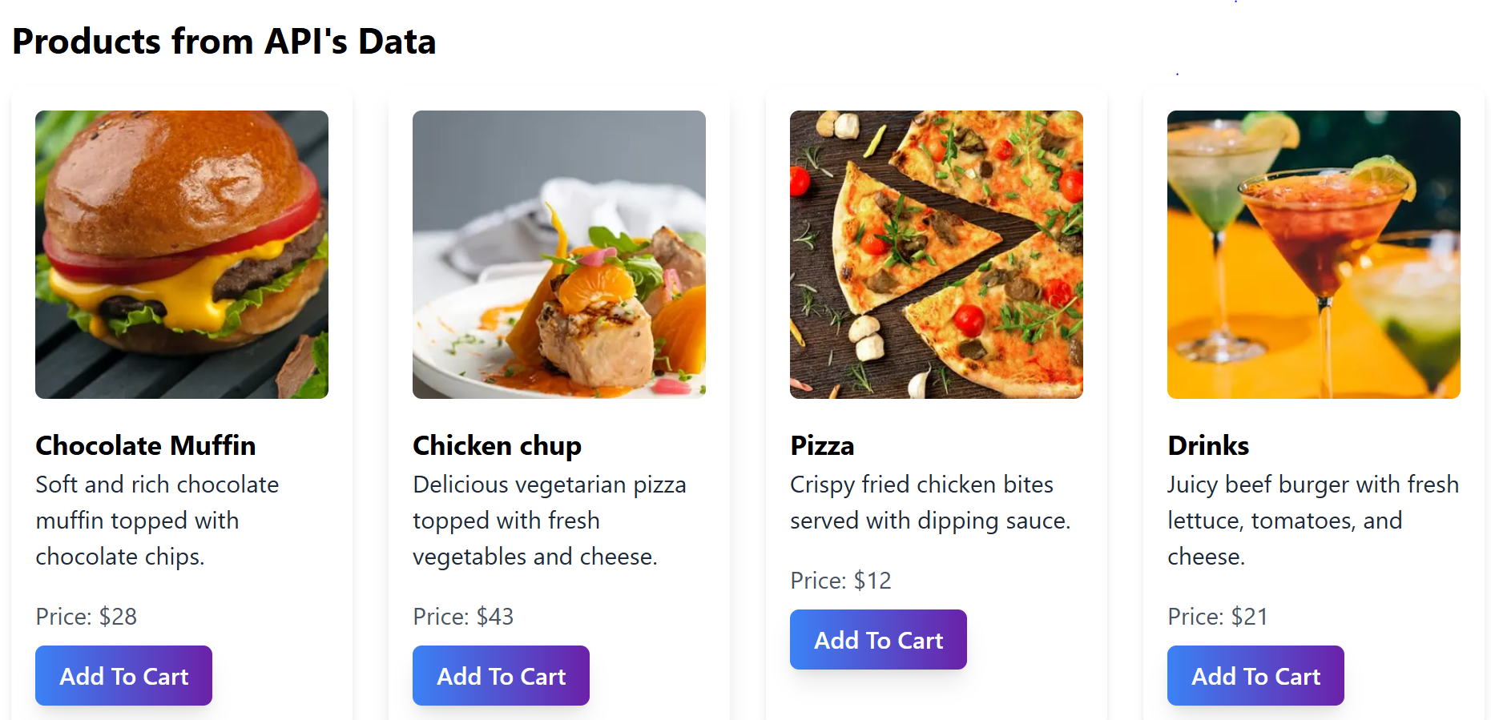

Mobile Responsive

The marketplace passed the responsiveness test without any issues. When tested on various screen sizes, the layout adjusted seamlessly, ensuring that all content (product listings, filters, and checkout buttons) was appropriately displayed. Elements like buttons, images, and text remained properly aligned, and no content was cut off or misplaced.

No errors were encountered during responsiveness testing. The website was fully responsive on popular devices, including desktop (Chrome), tablet and mobile.

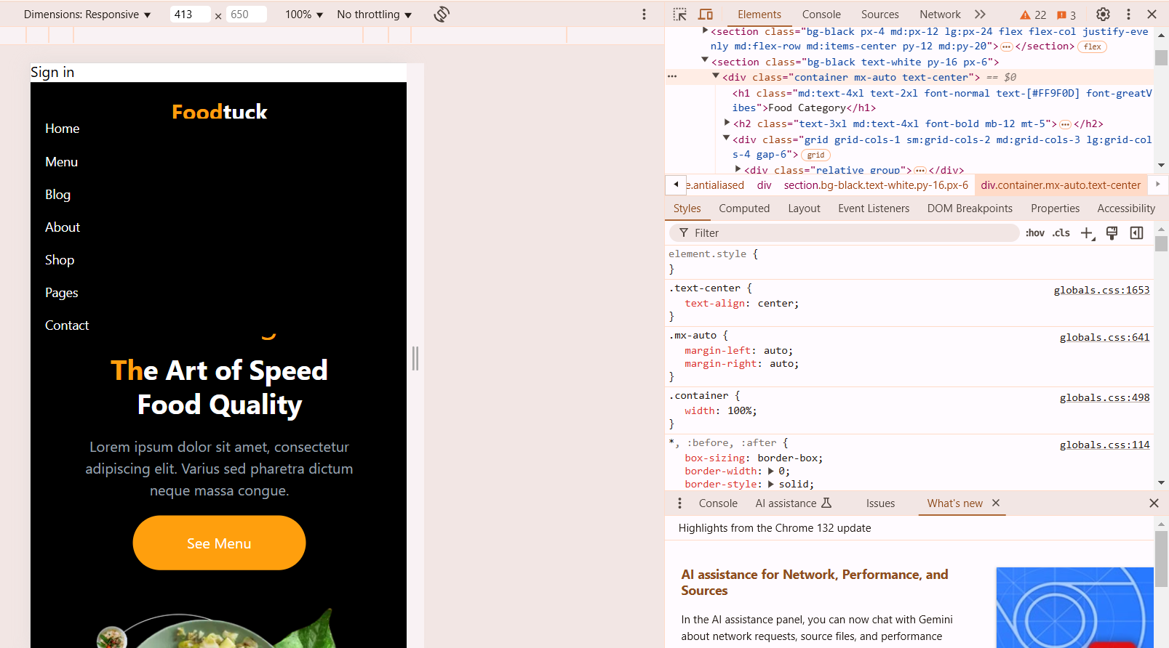

Checkout Process

**Problem Faced:**

During testing, it was observed that when users attempted to proceed to the checkout page with no items in the cart, the system did not prevent them from doing so.

Resolution:

To resolve this, a validation step was added to check whether the cart is empty before proceeding to the checkout page. If the cart is empty, the user is now presented with a clear message such as "Your cart is empty." After implementing the fix, the checkout process was tested again with an empty cart, and the system correctly displayed the error message, preventing users from proceeding further.

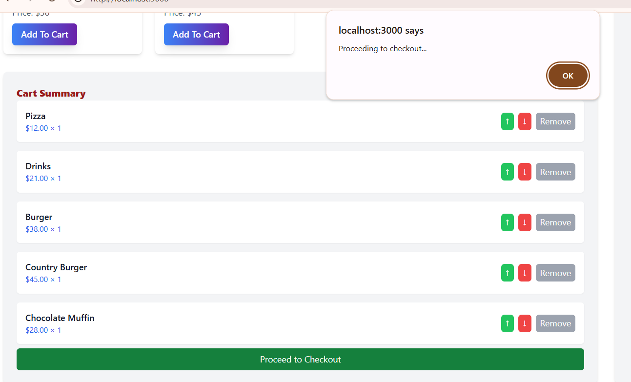

Security - Input Validation for Password Field

**Problem Faced:**

During security testing, it was found that the password input field did not have sufficient validation to prevent invalid inputs. This could potentially allow users to enter weak passwords or malicious scripts.

Resolution:

The issue was resolved by implementing proper input validation for the password field. The validation now enforces the following rules:

Minimum password length of 8 characters

At least one uppercase letter

At least one lowercase letter

At least one number

At least one special character

Prevention of common or easily guessable passwords

After implementing the validation, the system correctly rejected any input that did not meet the specified criteria, enhancing the security of user accounts.

LightHouse Security Validation

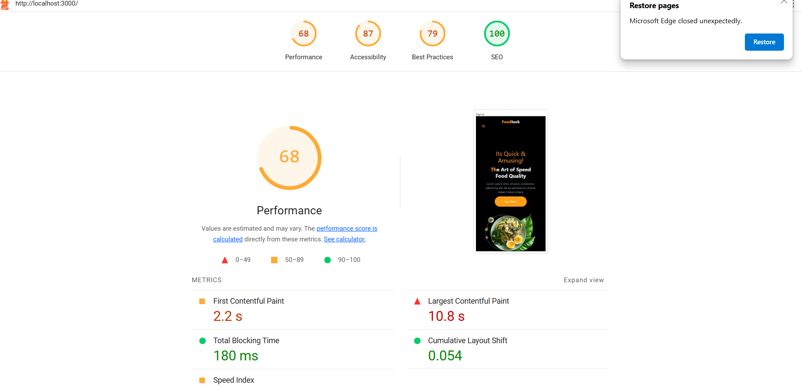

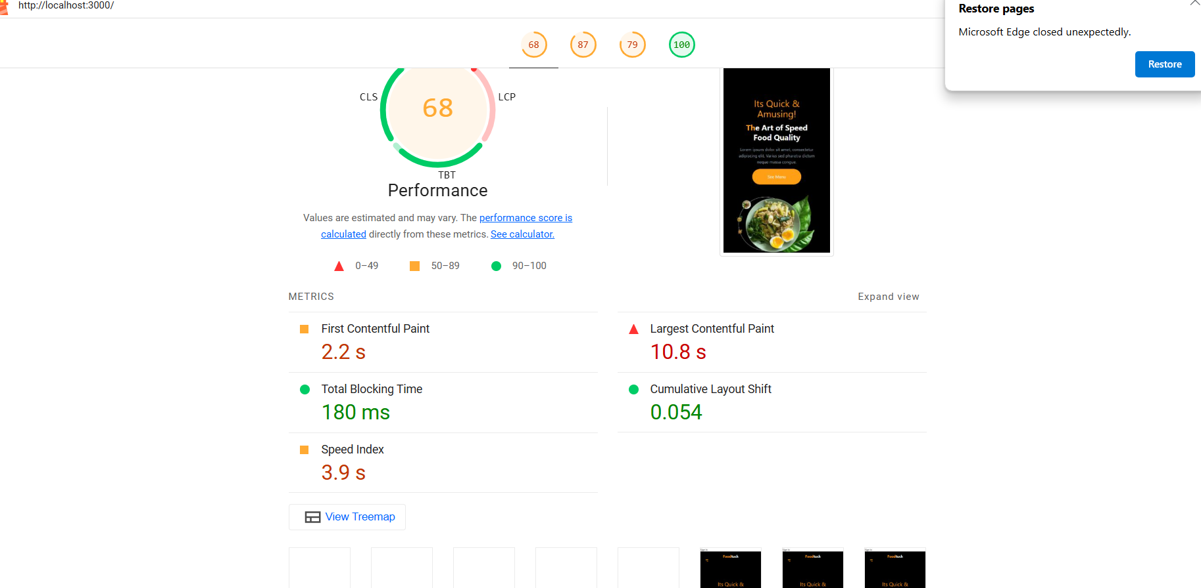

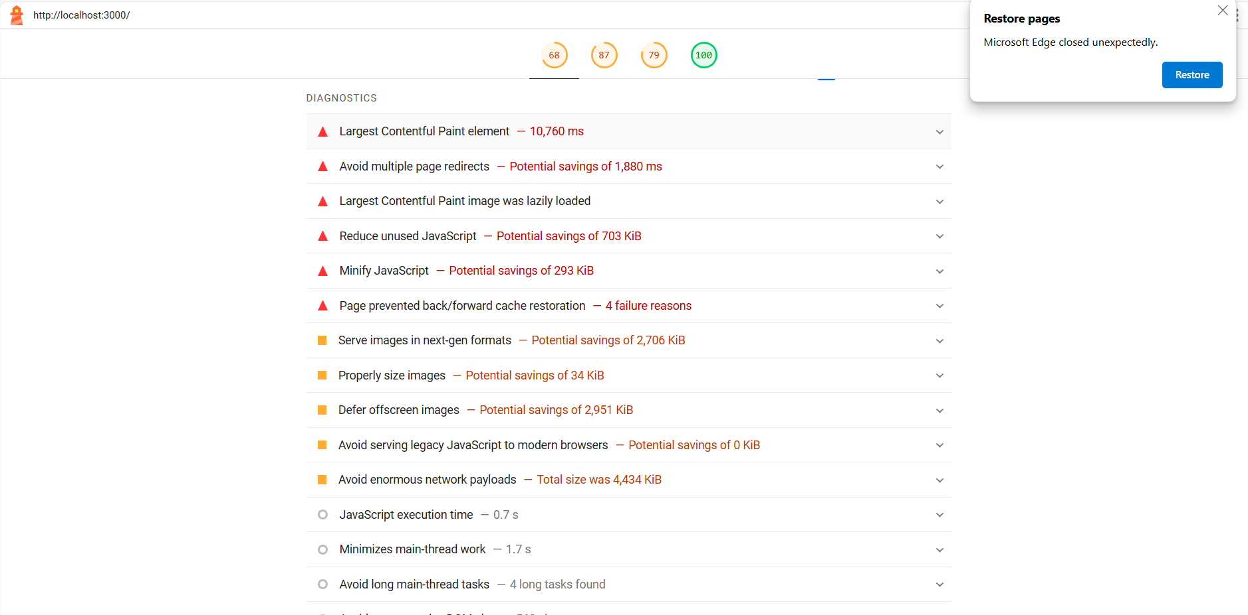

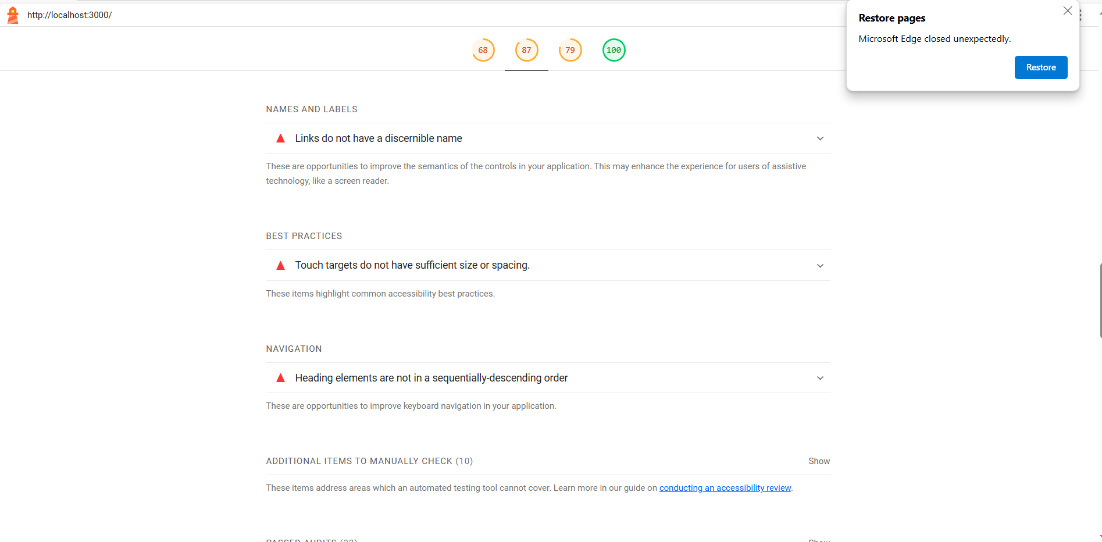

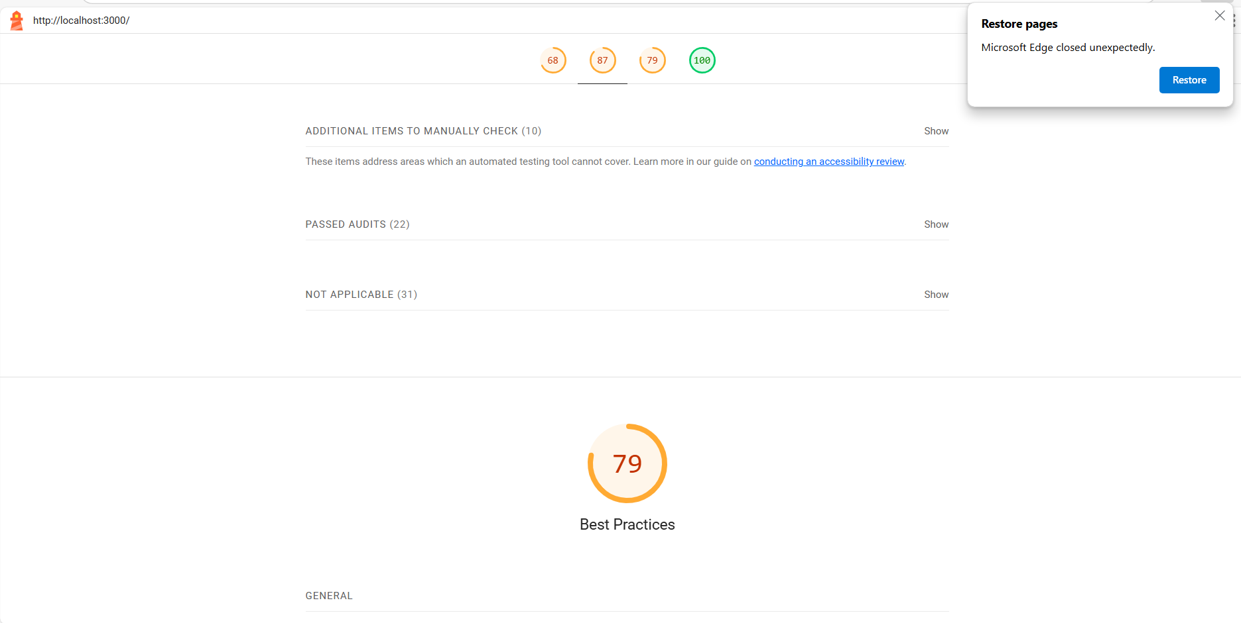

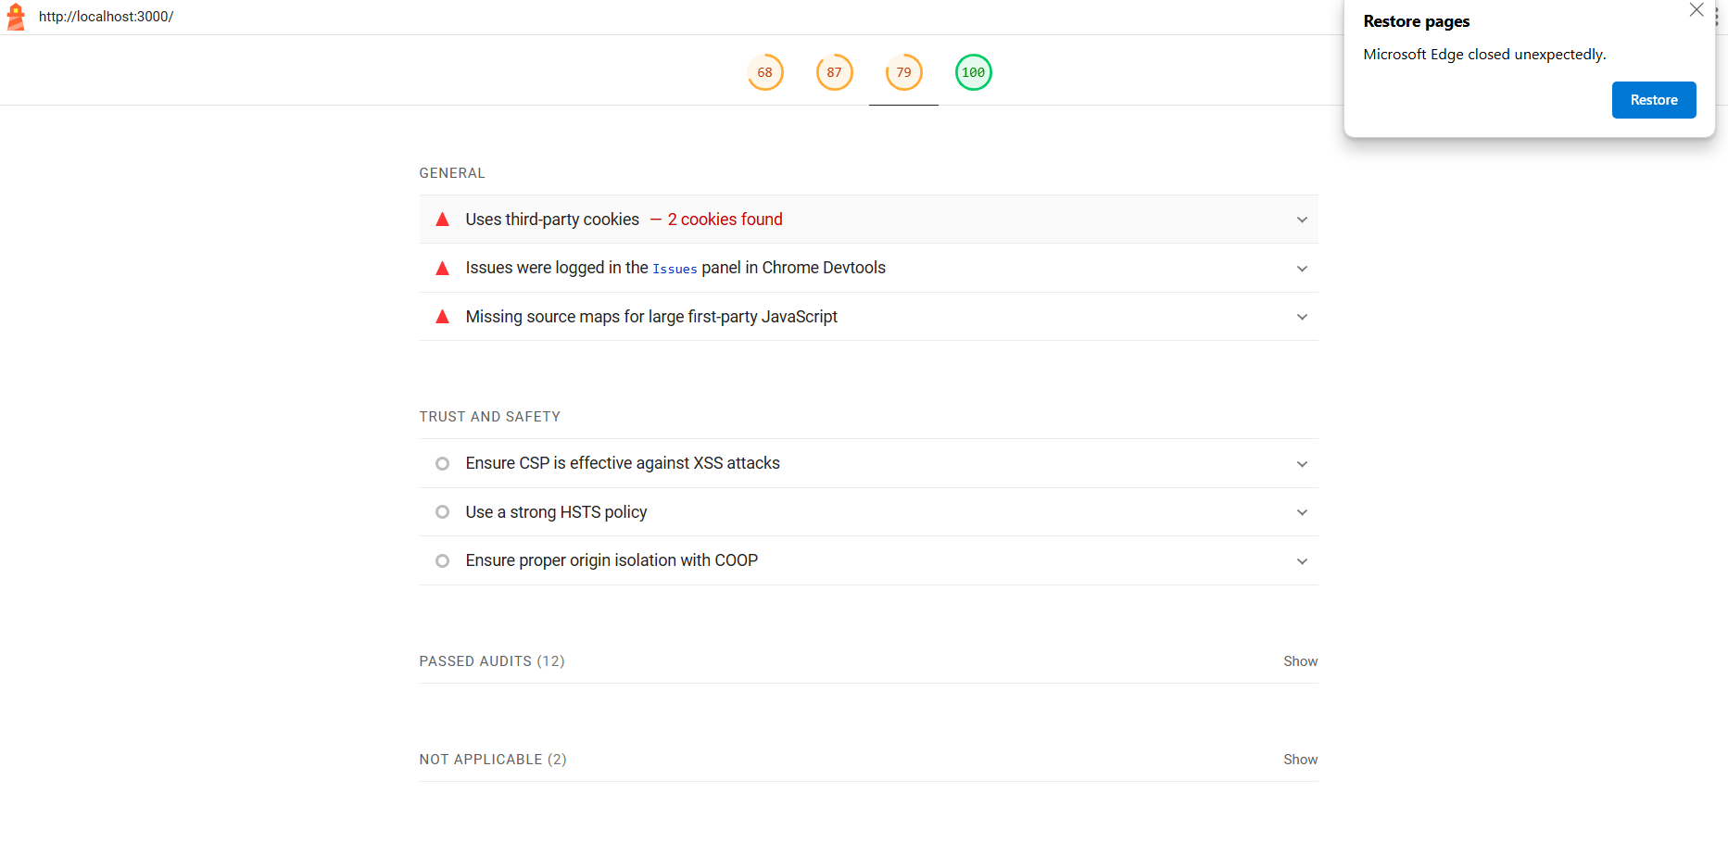

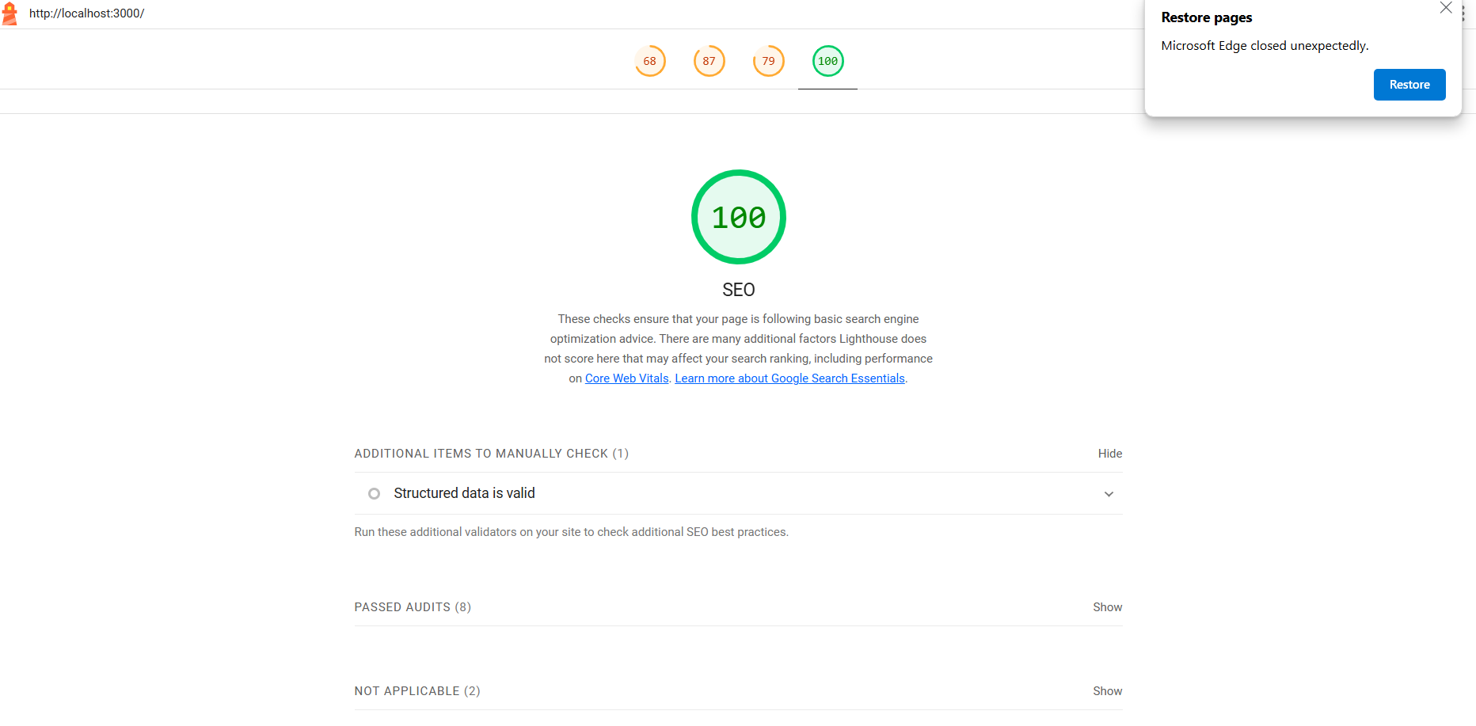

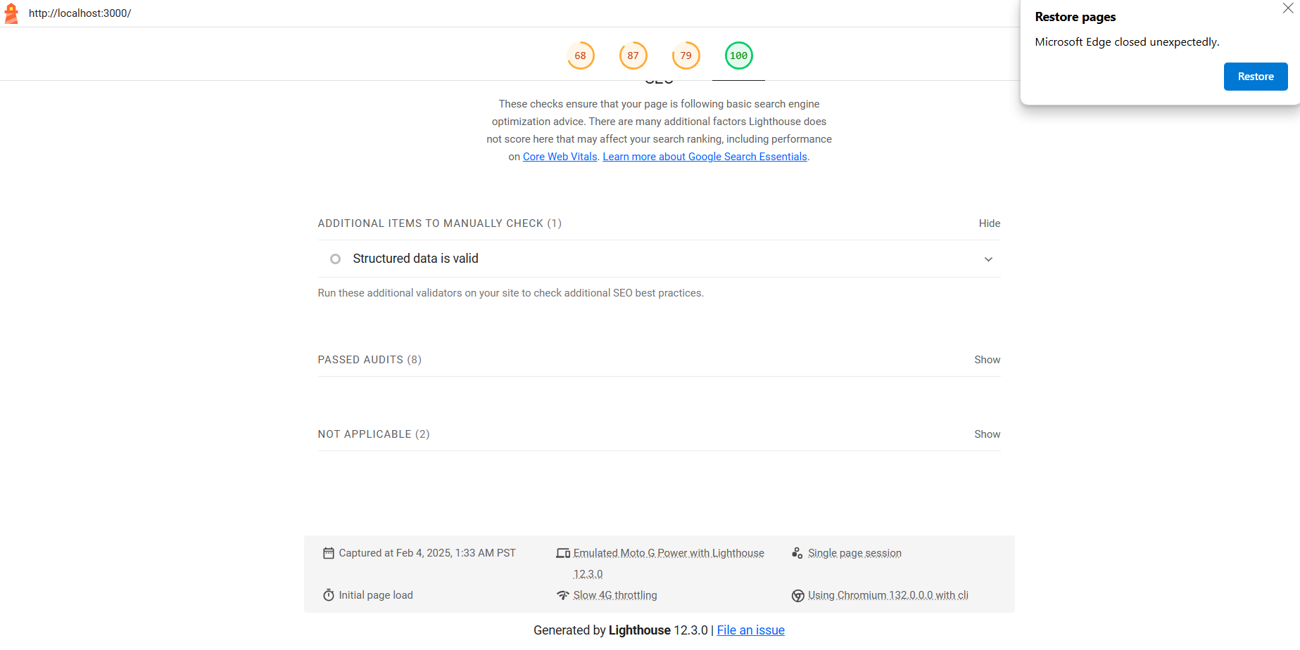

Security Overview

* Developer Resources

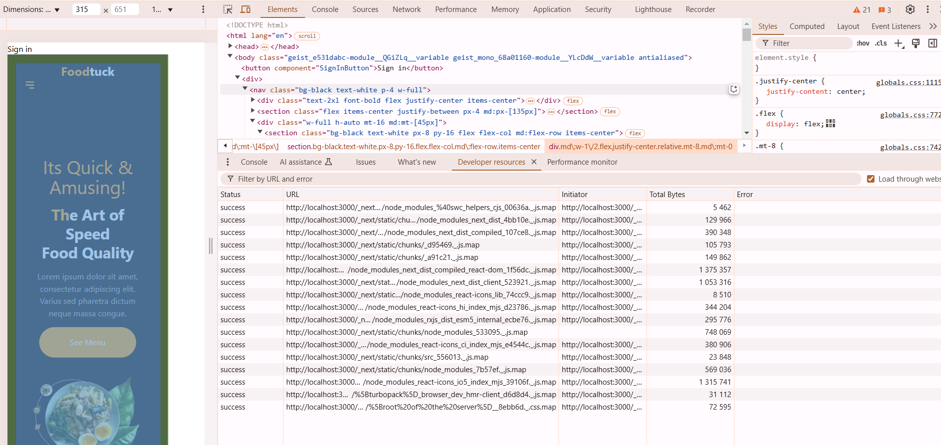

* Performance Monitor

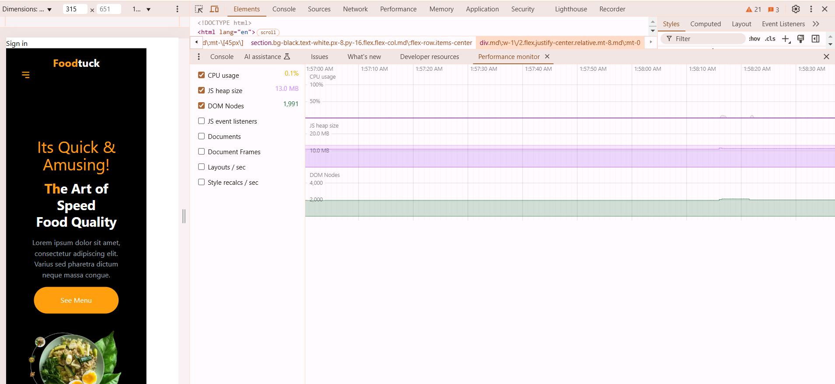

* Security

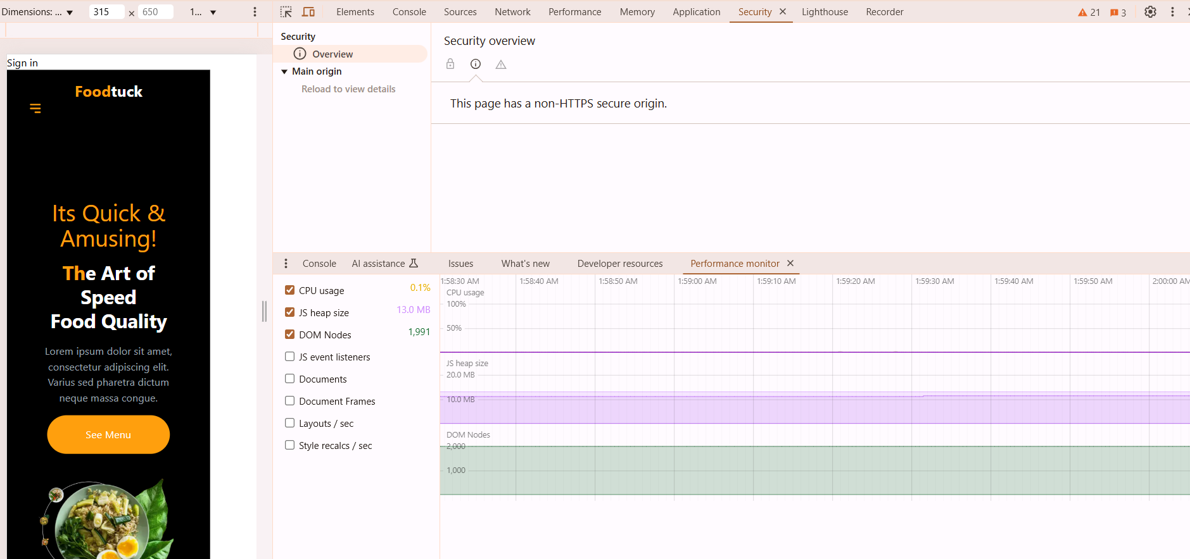

Conclusion

In conclusion, Day 5 of the testing, error handling, and backend integration refinement phase successfully addressed a variety of critical issues to ensure that the marketplace is ready for a seamless, user-friendly, and secure deployment. The primary focus areas included validating core functionalities, improving the user experience, and enhancing security measures.

Functional Testing

Error Handling

Security Improvements

Performance Optimization and Responsiveness

Cross Browser and Device Test

Product Search Functionality

The product search feature worked as expected without any issues. When users entered specific search terms, the results matched the query accurately, displaying relevant products based on title, description, and category.

No errors were encountered during the testing of the product search functionality. The feature performed optimally, displaying products in a quick and responsive manner. The user interface was clean, and the search results were displayed without delays.

Highlighted text in image

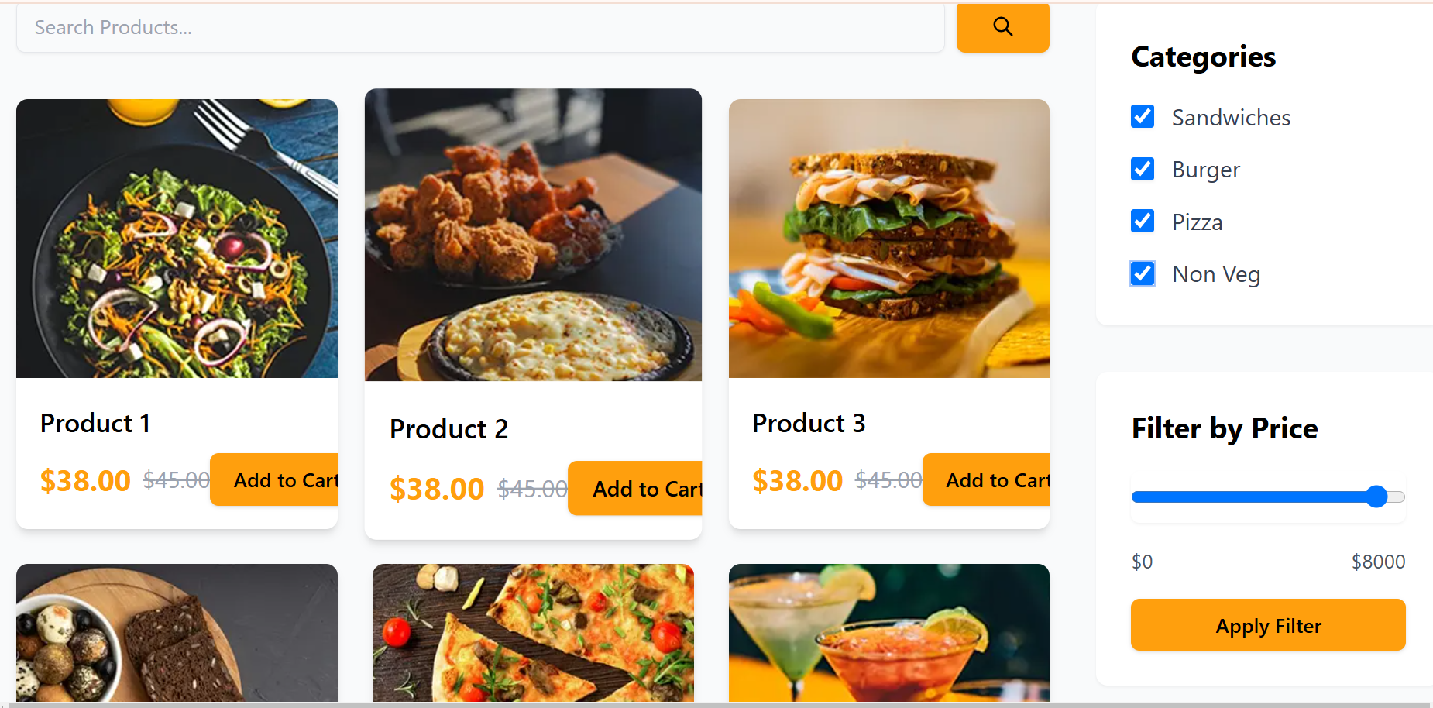

MarketPlace-Builder-

Hackathon

Day-5: Testing, Error handling and Backend Integration

Refinement

Overview

The main goal of DAY-5 was to prepare the marketplace for real-world deployment by thoroughly testing all components, identifying and resolving errors, optimizing performance, and refining backend integrations. This involved performing functional testing to ensure core features like product listings, search, and cart operations worked as expected, implementing error handling to display user-friendly messages and fallback UI for API failures, optimizing performance by reducing load times and compressing images, and conducting cross-browser and device testing to ensure consistent user experience. Additionally, security testing was conducted to validate inputs and secure API communication.

Product Listing Page

**Problem Faced**

During testing, while navigating to the product listing page, I observed that the images were not loading, and instead, an error message stating "Image fetch failed" was displayed. The issue was traced back to a network problem that caused the failure in fetching images from the sanity. This disruption was preventing the page from displaying the correct product images, which is a critical part of the marketplace's user experience.

**Resolution**

The issue was resolved by addressing the network connectivity problem. Once the network was restored, the image fetching functionality resumed as expected, and the product images were displayed correctly on the page. After the fix, the test was repeated, and the images loaded successfully without errors.

